Culinary Historians of Canada
Minutes of Annual General Meeting
Ratified at 2021 AGM – 26 September 2021

Saturday, September 26, 2020, 2 to 3:30 pm
Via Zoom

1.Welcome by the president
President Carolyn Crawford welcomed all to the 26th anniversary AGM. Julia Armstrong explained the mechanics of speaking, commenting and voting using Zoom for this meeting.

2. Land acknowledgement
Jennifer Meyer read an acknowledgement of traditional territory.
3. Approval of the agenda
Moved by Sarah Hood, seconded by Mark D’Aguilar, to accept the agenda as presented. Motion carried.

4 Minutes of the last AGM, Oct 5 2019 meeting
Moved by Sylvia Lovegren , seconded Fiona Lucas, to accept the minutes of the last annual general meeting as presented. Carried.

5. Election of officers Part A
Nominations from the floor: Fiona Lucas asked for nominations from the floor; none were received. Fiona declared nominations closed.

Introduction of candidates standing for election: Lori Jamieson introduced the candidates nominated:
President: Carolyn Crawford
Vice Presidents: Samantha George and Sherry Murphy
Secretary: Colin Rier

6. Treasurer’s report – Fiona Lucas
Fiona presented highlights of the year’s financial activity.

Background: As a non-profit corporation in Ontario with an annual income of less than $100,000, we must appoint a public accountant to conduct an annual financial audit, unless we waive the appointment and audit by a vote of 80 per cent majority at our annual meeting. If we waive the appointment of an accountant and audit, we must compile and publish a summary of our financial activity and the treasurer does this every year.

Moved by Mark D’Aguilar, seconded by Kesia Kvill: Be it resolved, by 80 per cent majority consent at this meeting, that the members of CHC:
- waive the appointment of a public accountant/auditor, and
- waive any audit of the financial statements
for fiscal year 2020-2021.

All in favour. None opposed. Motion carried.

7. Committee reports
Sylvia Lovegren, chair of Programme: Our last event before the Covid shut down was the launch of John Ota’s book The Kitchen. We launched our first Zoom series Behind Every Great Cook is a Great mother in May. We have two new members, Meaghan Froh Metcalfe and Liz Truchanowicz, who are bringing their considerable expertise to help us bring virtual events to our membership.

Samantha George, chair of Publicity: CHC has partnered with a Quebecois production company shooting a documentary about the home-front activities of Canadians through WWII. We might have an opportunity to work with them in the future. We are continuing to work with the Royal Agricultural Winter Fair as they refine their strategic plan.

Sarah Hood, co-chair of Communications– Thanks to Fiona Lucas who has updated the indices of Culinary Chronicles and added some valuable bibliographies as a resource to our website.
We have many key Canadian period cookbooks in the public domain now digitized in our website.

We have a YouTube channel and we are always looking for new content or ways to create content for that. Thanks to Julia Armstrong for all her effort to create and post Zoom content. We had a signal victory in creating a new website system for membership signup. Members can sign up now on the website, pay with PayPal and that automatically updates our membership list. We adapted the newsletter slightly to cover online activities and people have actively participated on our cooking challenges on our FaceBook channel. We have more than 2,000 participants there, and we are seeing great scholarship to questions posed there.

We print member news in every issue, and we’d love to print more stories about what members are doing, learning and want to share. We really do mean it – we want to hear from you.

Judy Chow, chair of Membership: We do want to expand our national membership. Judy Corser asked how she could contact other members in western Canada. Sarah and Judy referred all members to the membership directory, published every year on January 1; one of its prime purposes is to allow members to connect with each other.

Jennifer Meyer, coordinator of volunteers: Thanks for the outstanding efforts by volunteers who support CHC by helping with the newsletter, events.

Members were polled about volunteer opportunities. Results:

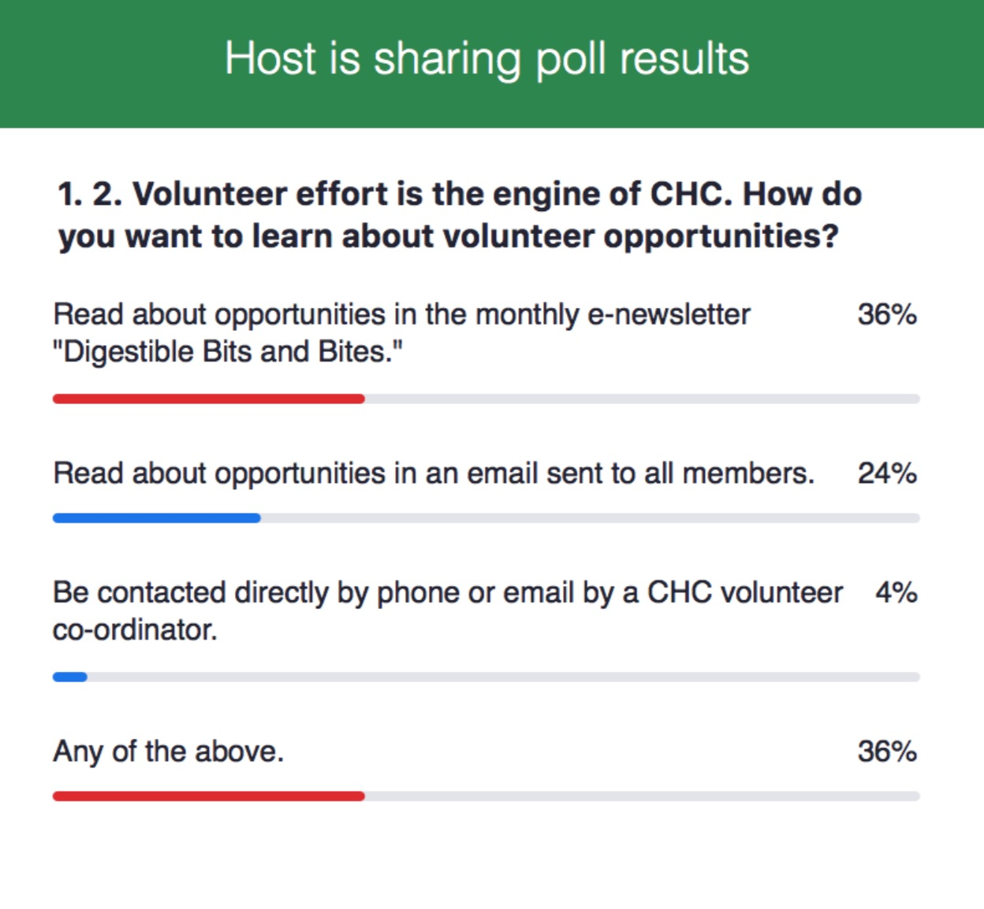
President Carolyn Crawford asked what people had baked for the meeting, and many shared. Oatmeal cookies, hermits, brownies, pizza and butter tarts were popular.

Ellen Pekilis, chair of strategic planning, discussed the strategic planning process undertaken by executive since March 2020. She talked about how a good planning process supports taking scarce resources and making the most of them.

Three core strategic priorities: engaging members, reaching everyone (getting to the heart of achieving a national presence), and increasing capacity. We have a draft 3 year plan to be confirmed by the new board.

Members were polled about CHC membership. Results:

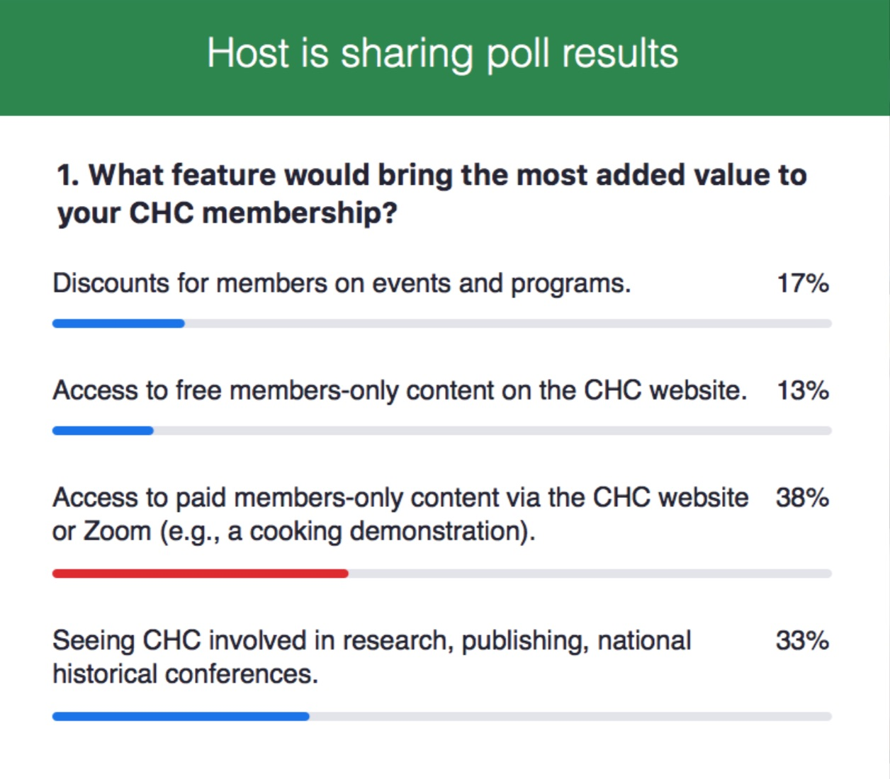
8. Election of Executive officers Part B
Moved by Lori Jamieson, seconded by Ellen Pekilis, that the following members be acclaimed to the CHC executive for two-year terms 2020 to 2022.
President: Carolyn Crawford
Vice presidents: Sherry Murphy and Samantha George
Secretary: Colin Rier
Carried.

9 Confirmation and introduction of appointed Committee chairs for 2020-21
Chair, Membership Committee: Judy Chow
Chair, Programme Committee: Sylvia Lovegren
Co-Chairs, Communications Committee: Julia Armstrong and Sarah Hood
Chair, Education Committee: Jane Black
Coordinator of Publicity: Samantha George
Coordinators of Refreshments: Sherry Murphy & Carolyn Crawford
Coordinator of Volunteers: Jennifer Meyer
Chair, Outreach: currently vacant

10. Honorary Membership Award:
To date, The Culinary Historians of Canada have recognized 10 members for their extraordinary contributions to Canada’s food history. The 2020 award was presented to Rose Murray.

Through her writing, teaching, and television and radio appearances across Canada, Rose has shaped our perspective of Canadian cuisine. She has authored over ten books including two Taste Canada Gold Award winners―Canada's Favourite Recipes (with Elizabeth Baird, in 2012) and Hungry for Comfort (in 2003).
Her first work, The Christmas Cookbook, remains a treasured Canadian kitchen resource, and she has contributed to many other books, including many for Canadian Living. Her latest book, Rose Murray’s A-Z Vegetable Cookbook, was originally published in 1983 and has been revised to include an additional 100 recipes developed by home cooks across Canada.

Rose is respected for her understanding of the agricultural traditions of our food. Beginning in her childhood on a mixed farm near Collingwood, Ontario, she learned the art of growing, cooking and preserving her own food at a very young age. She has blended her university degree in English from Trinity College, University of Toronto, with formal studies at cooking schools in Paris as well as classes in Costa Rica, Hong Kong and Thailand.

Rose has been a member of the Culinary Historians of Ontario and later Canada since our inception in 1994. She's been a teacher and ever-willing volunteer for many CHC events. Her 2019 presentation on her dear friend Edna Staebler was captured for our archive, and she recently shared her story as part of our 2020 video series on great cooks and their mothers.

11. Sylvia Lovegren thanked Lori Jamieson, outgoing secretary, for her work on the CHC executive.
12. Date of next annual general meeting: September 26, 2021.

12. Adjournment

Members attending 2020 AGM (held via Zoom)
Simone Collins
Stephanie Thomas
Sylvia Lovegren
Susan Peters
Tracey Bloem
Vicki Gregor
Lori Jamieson
Julia Armstrong
Ellen Pekilis
Rose Murray
Colin Rier
Elizabeth Baird
Elka Weinstein
Fiona Lucas
Jennifer Meyer
John Ota
Judy Chow
Judy Corser
Kesia Kvill
Margaret Proctor
Mark D’Aguiler
Nora Gubins
Rhonda Flanagan
Samantha George
Sarah Hood
Sherry Murphy
Carolyn Crawford

